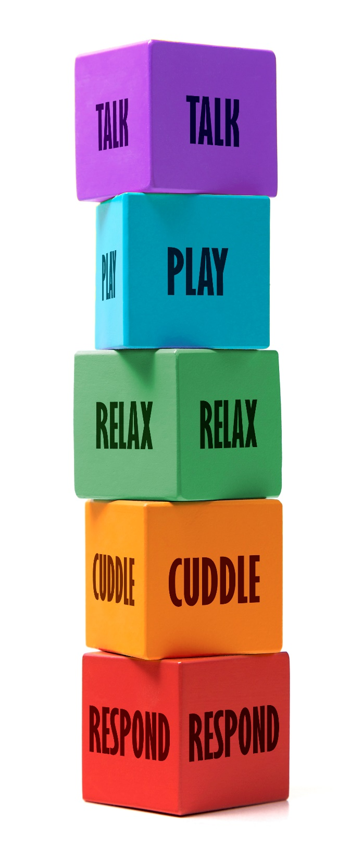
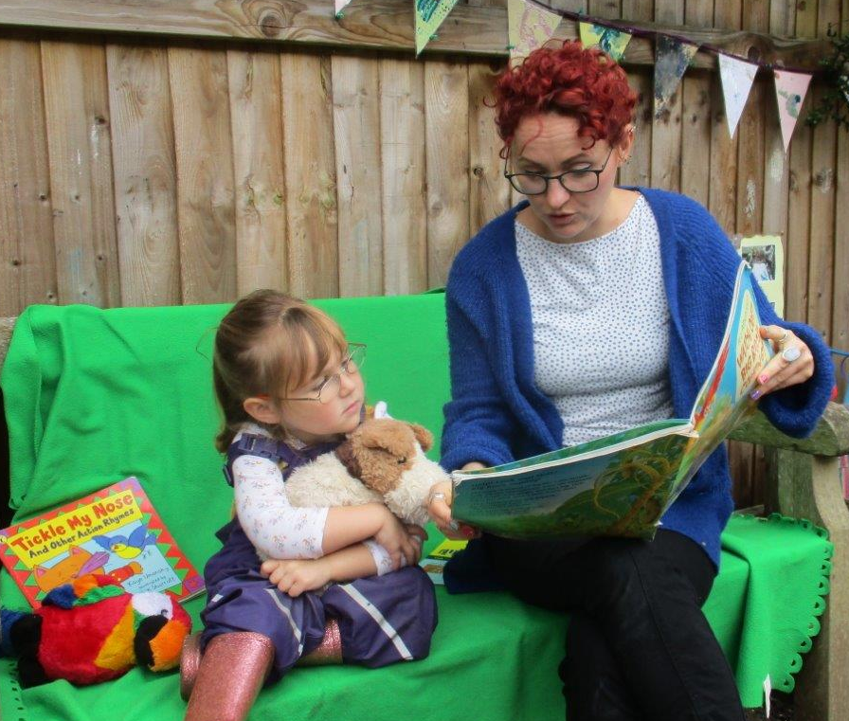
Reading together…
TALK- ‘It’s fun when you read to me using different voices and sounds for characters. I like it when you talk about and describe what we both see and link it to my own experiences.’

PLAY- ‘I like it when you use my toys and actions when you are reading to me and how we make the story come alive through play’

RELAX- ‘I feel close to you when we read a book together. It helps us
to relax and find out new things. I like it when you read to me before
I go to sleep…’
CUDDLE- I like it when you sit close to
me when you are reading me a story,
I feel warm, safe, secure and loved.
RESPOND- I enjoy it when we talk about
the story and how you celebrate my
achievements when I recognise new
things and learn new words.

