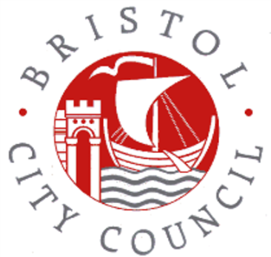
Free Early Education Entitlement (FEEE)
EYR19 – Rates for 2026-2027

Please see the table below for the hourly rates, as agreed by the Full cabinet,
April 2026 – March 2027 (inclusive)
Age | Hourly Rate paid to BCC by DfE | Hourly Base Rate paid to Providers | Difference | What is the difference paying for?
Under 2’s | £12.71 | £11.32 | £1.39 | EY SEN Panel, Deprivation, System leadership, centrally retained funding (limited to 3%)
Eligible 2 Year Olds | £9.23 | £8.72 | £0.51 | EY SEN Panel, Deprivation, System leadership, centrally retained funding (limited to 3%) & National Insurance Contributions and Teachers Pension Grant.  3 annual places for 2-year-old children who are in need
2 Year Olds from working families | £9.23 | £8.42 | £0.81 | EY SEN Panel, Deprivation, System leadership, centrally retained funding (limited to 3%) & National Insurance Contributions and Teachers Pension Grant.
3 and 4 Year Olds | £6.69 | £6.01 | £0.68 | EY SEN Panel, Deprivation, System leadership, centrally retained funding (limited to 3%) & National Insurance Contributions and Teachers Pension Grant.
Early Years Pupil Premium | £1.15 | £1.15 | None | n/a
Disability Access Fund | £975 | £975 | None | n/a
Maintained Nursery School Supplement | £5.47 | £5.47 | None | n/a
Additionally, providers with children from areas of disadvantage get an hourly deprivation rate added to their hourly rate for all ages, evaluated each January.

Breakdown of each rate as a visual
Under 2s
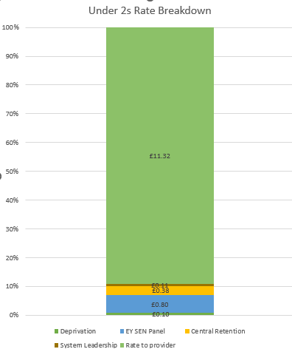

Eligible 2 year olds
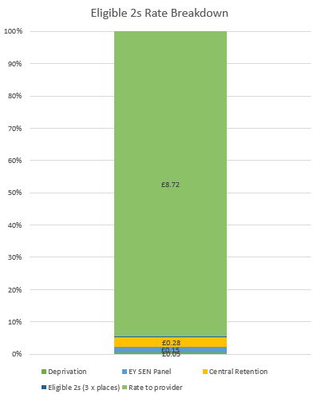

2 Year Olds from Working Families
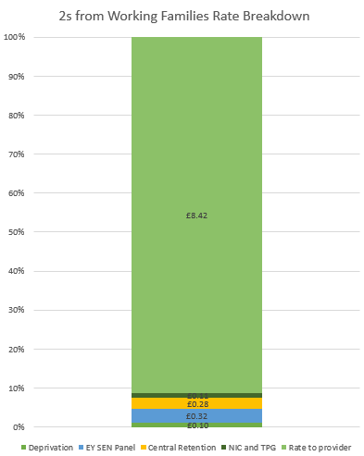

3 and 4 Year Olds

