
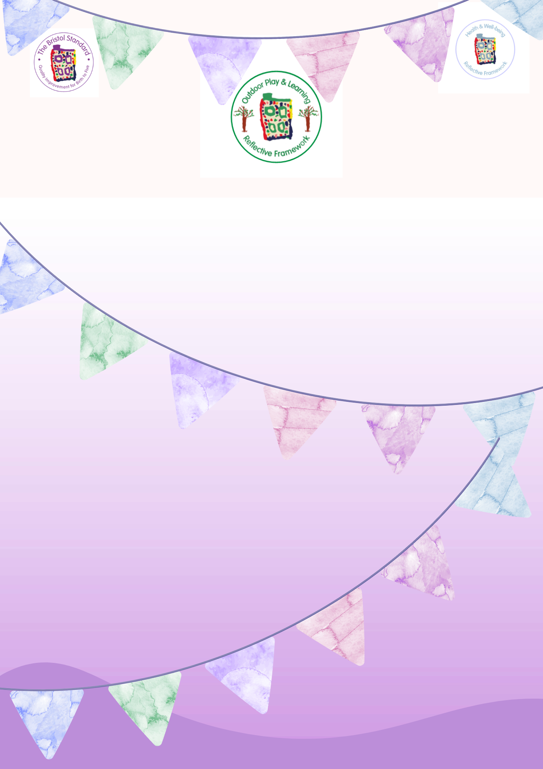
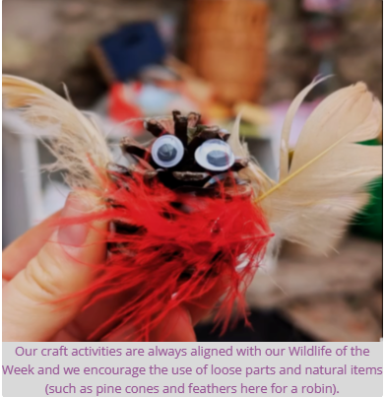
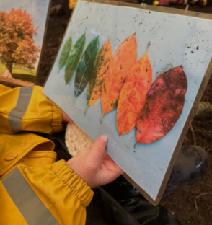
hv
For more information about starting and being supported along your quality improvement journey contact your Lead Teacher.

Benefits to children
Our craft activities are always aligned with our ‘Wildlife of the Week’ and we encourage the use of loose parts and natural items (such as pine cones and feathers here for a robin)

Working with the conservation and gardening team in WWPF so that children can take an active part in conservation and looking after the
park environment.

We watch and notice as the seasons turn and look for signs of changes all around us.
Embedding the children's understanding of how to take care of their environment and actively valuing their surroundings. Working in partnership with other members of the community and learning about what they do to support the environment in which they play and learn.

Target
Seasonal and Child-Led Learning
We take a flexible, seasonally-inspired curriculum, which ensures that
children develop a deep connection to nature and an understanding
of its cycles. Through initiatives like Wildlife of the Week (WOW), we weave
embedded learning opportunities across multiple areas, including literacy,
numeracy and the arts. Each week, children explore a featured wildlife
theme that is reflected in our activities, reading materials, and even meals.
For example: If ducks are in the pond, we may take an impromptu visit to
observe them, sparking discussions around movement, habitats and the
water cycle.
On rainy days, we embrace the weather by splashing in puddles and engaging in water and mud play, encouraging sensory exploration and scientific inquiry.
In autumn, children experience the changing leaves first-hand, incorporating discussions on colours, textures, and the life cycle of trees into our play.
Our In-The-Moment planning approach ensures that learning is always relevant and meaningful. Educators are skilled at observing children's emerging interests and adapting activities accordingly, whether it’s exploring shadows to learn about light and shape on a sunny day or turning an impromptu stick collection into a creative project. Following the children's spontaneous interests, such as the morning a child expressed curiosity about bows and arrows, leading to an activity where children gathered sticks and string to create their own. This hands-on experience encouraged problem-solving, creativity, and discussions around history and tool-making.
Foraging for wild garlic in the park to incorporate into cooking activities. This ability to respond spontaneously supports children in becoming curious, engaged learners.

Strength

