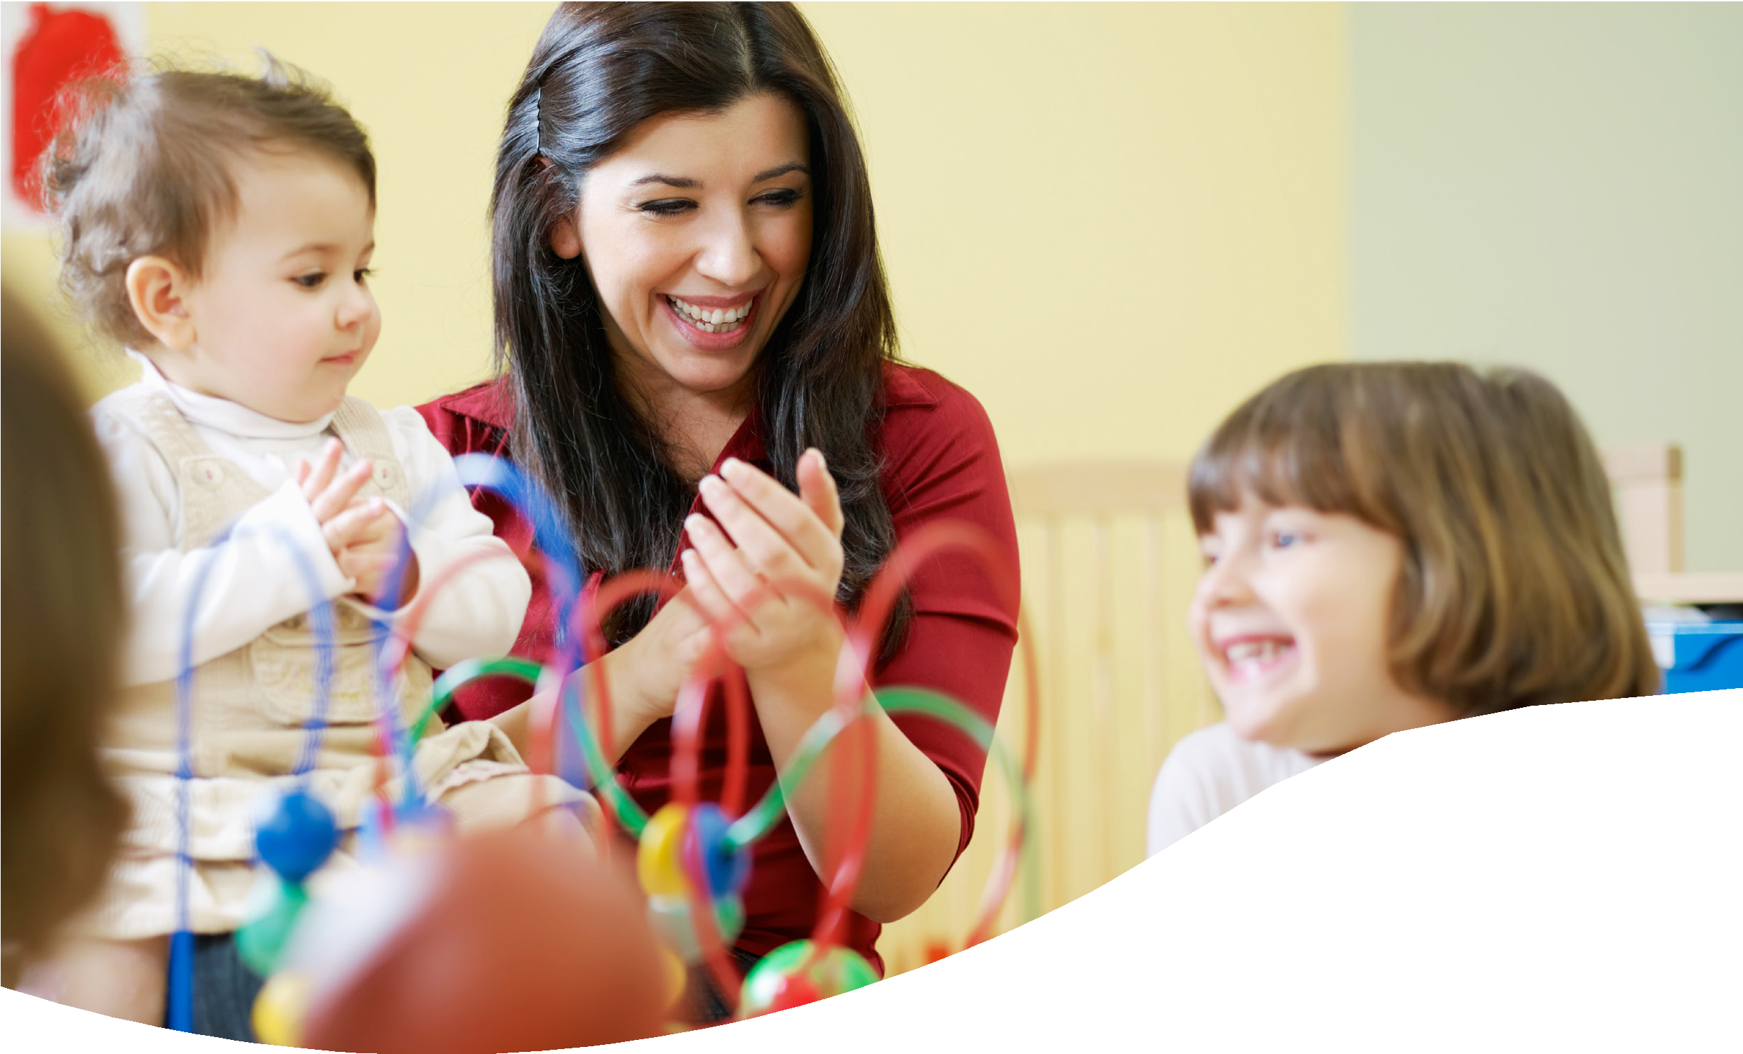

Educational Psychology

Work in Early Years
A Guide for Parents, Carers, and Families

EDUCATIONAL PSYCHOLOGY - EARLY YEARS

Table of Contents

What is an Educational Psychologist? | 3
What do Educational Psychologists do? | 4
How can I prepare? | 5
Accessing support from an Educational Psychologist | 6
Useful contacts and links | 7

What is an Educational Psychologist?

Educational Psychologists (EPs) apply psychology to help us
to understand a child’s development, learning, behaviour, communication, and/or emotional wellbeing in context.

We work collaboratively with parents and professionals to identify the best ways to support a child.

EPs have training and postgraduate qualifications in education, psychology and child development. They are regulated by the Health and Care Professions Council.

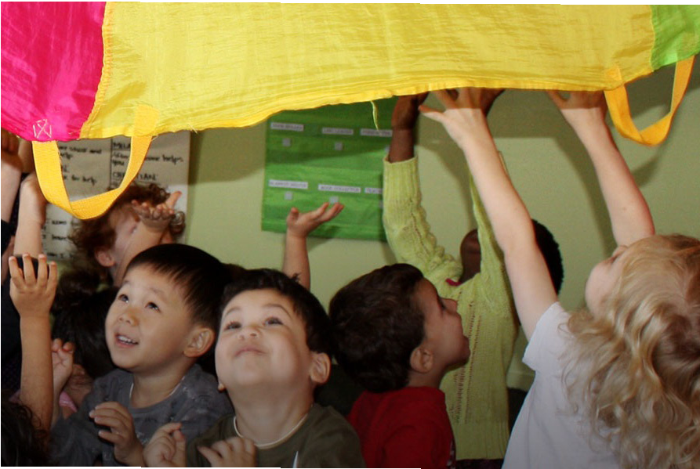
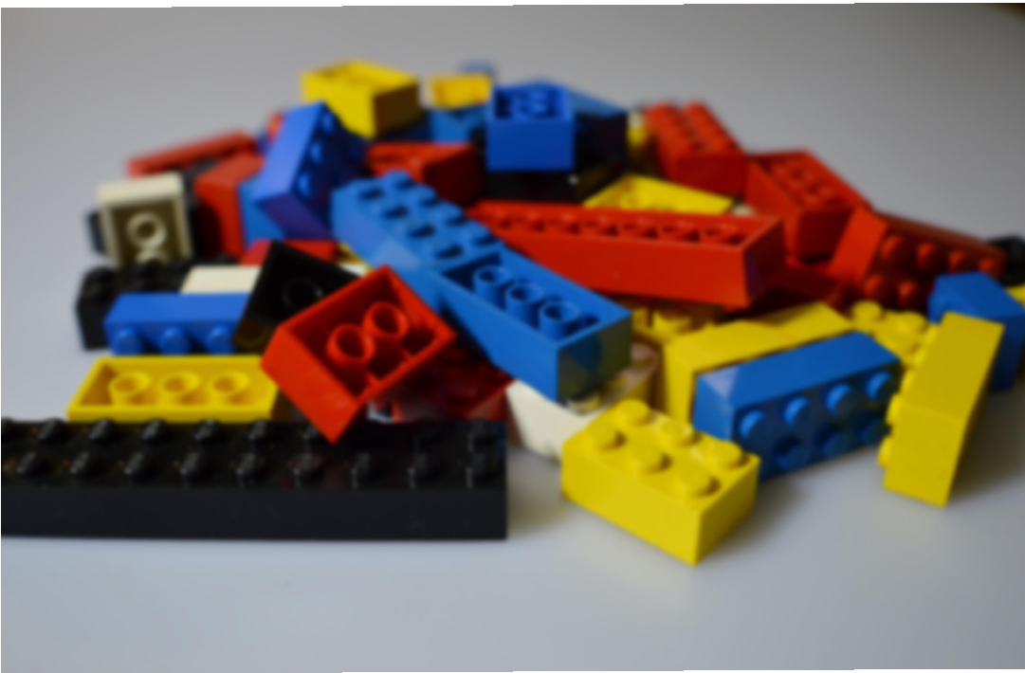

What do Educational Psychologists do?
An EP carries out work in mainstream schools, nurseries, children’s centres, specialist educational provisions, community centres, and with families at home.

When working with you and your child we might:
- observe your child in their setting
- play alongside your child
- use a strengths-based video intervention to develop your understanding of your child
- hold a consultation with you and key staff
- and write short report summarising the discussion

What is an EP Consultation?
An EP consultation is a collaborative discussion between parents, early years staff, and the Educational Psychologist. The purpose is to build a shared understanding of your child's development, learning, behaviour, communication, and wellbeing.

During the consultation, we will:
- Talk about your child's strengths and interests.
- Explore any concerns you may have.
- Consider factors that might influence your child's development and wellbeing.
- Agree practical strategies and next steps to support your child.

How can I prepare?

As a parent or carer, you know your child best, so hearing your views is an essential part of the consultation process. Sometimes, it can help to think about the questions below before the meeting.

If you don’t have time, don’t worry, the EP can also guide you through this during the meeting.

Areas of strength
- What does my child love?
- When are they at their best?
- What do I do that already works well to support my child?

Areas of need or concern
- What does my child find hard?
- What makes things difficult for them?

Hopes for the future
- How would I like things to be different for my child?
- What would I see if things were better?

Accessing support
Through discussion, SENDCo and parent decide that EP support would be beneficial.

The early year’s setting then sends the form to the Early Years SEN Panel.
The original form can be used with attachment asking for additional EP time.

The requests are then discussed by the Early Years SEN
Panel (an EP is part of that panel). The panel takes place on the second Wednesday of each month.

EP involvement is agreed.
Setting is informed by panel with suggested ways forward.

The EP service is contacted by the panel with an agreed allocation of time.
Reapplications will be considered.

The EP contacts the setting, a date is set and the work is completed.

The work is evaluated (Plan, Do, Review).

If more time is required
Useful contacts and links

Trading with Schools
Email: EPbusinessadmin@bristol.gov.uk
Web address: www.tradingwithschools.org

Bristol Early Years Educational Psychology:
Educational Psychology - Bristol Early Years

Bristol SEND Local Offer:
www.bristol.gov.uk/bristol-local-offer

