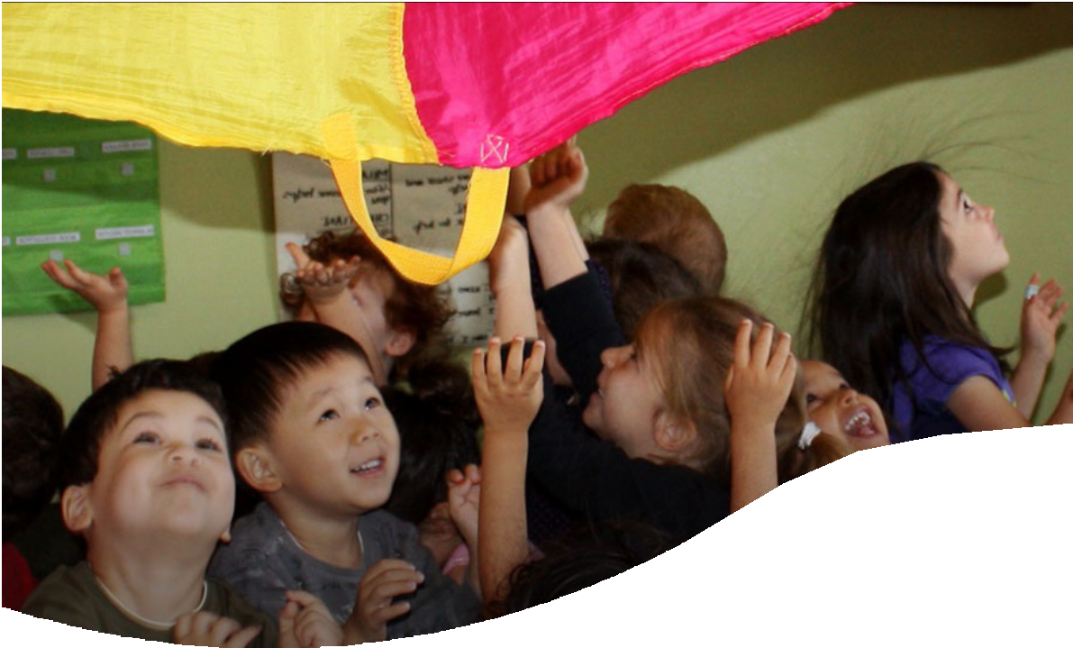

Educational Psychology

Work in Early Years
A Guide for Practitioners

EDUCATIONAL PSYCHOLOGY - EARLY YEARS
Table of Contents

What is an Educational Psychologist? | 3
What do Educational Psychologists do? | 4
Accessing support from an Educational Psychologist | 4
Additional EP Support | 6
Useful contacts and links | 7

What is an Educational Psychologist?
Educational Psychologists (EPs) apply psychology to help us
to understand a child’s development, learning, behaviour, communication, and/or emotional wellbeing in context.

We work collaboratively with parents and professionals to identify the best ways to support a child.

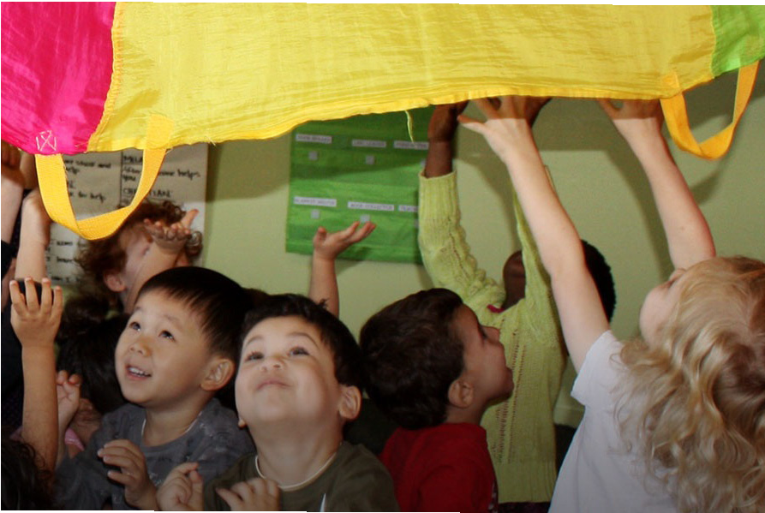
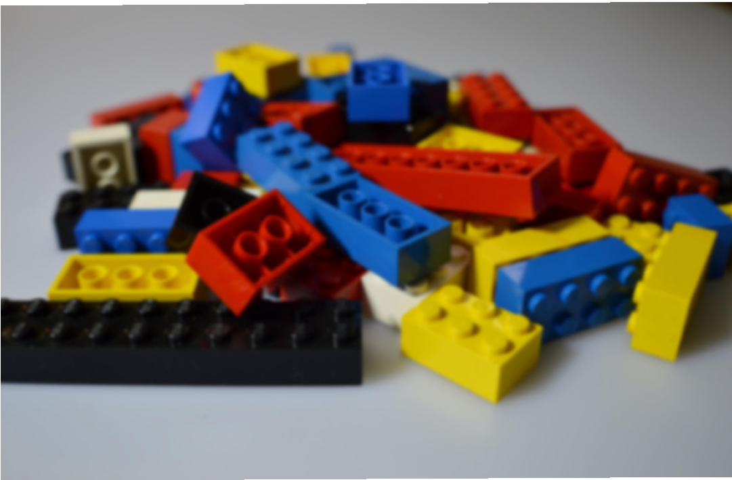
EPs have training and postgraduate qualifications in education, psychology and child development. They are regulated by the Health and Care Professions Council.

What do Educational Psychologists do?
An EP carries out work in mainstream schools, children’s centres, specialist educational provision, community centres and with families at home.

They provide training, consultation, assessment and advice on interventions for individuals or groups of children and young people. EPs also provide an immediate response and advice following critical incidents.

If a child is seen by an EP, they most commonly observe in the setting, hold a discussion with parents/carers and key adults, and write a short report. This report will include some next steps.
Involvement from the EP Service may include:
- Observation and play-based assessment to explore a child’s learning and development
- EP consultation with parents and key setting staff
- Person-centred meetings (e.g. Planning Alternative Tomorrows with Hope, PATH meetings)
- Transition support
- Video based intervention including
  - Video Interactive Guidance (VIG) work with practitioners or families, or
  - Video Enhanced Reflective Practice (VERP) with groups of practitioners
- Staff supervision – 1:1, group or drop in slots
- Staff training and continued professional development
- Support with early years setting policy development

If you would like support that is more bespoke, please include further details in the EP request for involvement form.

Accessing support from an Educational Psychologist

When you are concerned about an aspect of a child’s development, such as their progress in learning or their well-being, taking a ‘graduated response’ is recommended.

This means that you start by making the smallest change to see if that makes a difference and gradually increase what is done only if necessary.
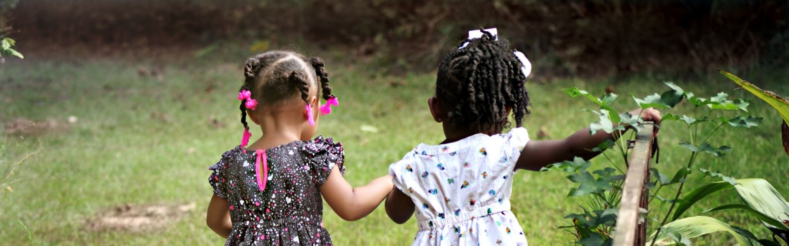

For example, if you are concerned about a child’s interactions and play, you might wish to start with some setting-based observation and intervention and review this as a team.

We would also encourage you to reach out to the team of practitioners around your setting (e.g. Early Years Portage and Inclusion Service). These steps are part of an assess-plan-do-review approach to SEND.

Should you feel you need more support or a different perspective, a request for EP involvement can be made to the monthly Early Years Panel. There are separate sections on the form for requesting individual involvement for a child or systemic involvement (e.g. training, video groups, or supervision). Please find the form here: www.bristolearlyyears.org.uk/ inclusion/send/educational-psychology/

The EP process:
NO
YES
The early year’s setting completes the request for involvement form with the family (signed and dated).
The form is sent to the Early Years SEN Panel: earlyears.senpanel@bristol.gov.uk
The requests are then discussed by the Early Years SEN
Panel (an EP is part of panel). The panel takes place on the second Wednesday of each month.
The EP contacts the setting, a date is set, and the work is completed within 6-8 weeks from the panel date.
The EP service is contacted by the panel with an agreed allocation of time.
EP involvement is agreed.
Reapplications will be considered.
Setting is informed by panel with suggested ways forward.

If more time is required
The original form can be used with attachment asking for additional EP time.

Useful contacts and links

Trading with Schools
Email: epbusinessadmin@bristol.gov.uk
Web address: www.tradingwithschools.org



Bristol Early Years Educational Psychology:
Educational Psychology - Bristol Early Years

Bristol SEND Local Offer:
www.bristol.gov.uk/bristol-local-offer

